**Unit Testing, JUnit, & Integration Testing**

**Introduction**

1. [*Unit Testing*](https://en.wikipedia.org/wiki/Unit_testing) refers to testing software at the lowest level. For object-oriented programming, usually that is a class. Unit tests are usually written by the developer. Usually, unit testing means testing each class in isolation. In other words there is not dependency on another class, a database, file system, or communication across a network.

Integration testing involves combining unit tested modules into larger structures and testing.

1. In order to automate unit testing, the code being tested is usually executed within a framework. A common framework for Java is [JUnit](https://en.wikipedia.org/wiki/JUnit)., which is integrated into Eclipse. There are [frameworks](https://en.wikipedia.org/wiki/JUnit#Ports) for unit testing for many languages. The remainder of these notes assumes you are using JUnit.
2. A unit test for a class is composed individual test cases where each test case is implemented as a separate method inside a test class. This general steps in each test method are:
3. Create expected output
4. Create object to be tested
5. Call method being tested and extract actual output
6. Compare expected and actual output
7. The way that the expected and actual output are “compared”, is to *assert* something about the output that must be true for the test to be consider successful (pass), otherwise it fails. Often, we assert that the expected and actual output are equal:

*assertEquals*(3, person.getNumAccounts);

*assertEquals* is a method in the JUnit framework that compares the two arguments. If they have the same value then the framework records this test as passing.

Or, some condition is true:

*assertTrue*(course.isClassFull());

*assertTrue* is a method in the JUnit framework that accepts a boolean expression. If the expression is true, then the framework records this test as passing.

1. The framework runs all test methods and provides a summary at completion.
2. 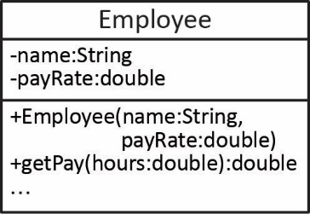Example – Consider the *Employee* class shown on the right where we want to test the *getPay* method shown below:

**public** **double** getPay(**double** hours) {

**if**(hours>0.0)

**return** hours*payRate;

**return** 0.0;

}

A test case in a JUnit test might look like this:

**void** test_getPay_positive_hours() {

**double** expectedPay = 800.00;

Employee e = **new** Employee("dg", 20.0);

**double** actualPay = e.getPay(40.0);

*assertEquals*(expectedPay, actualPay);

}

**JUnit in Eclipse**

1. 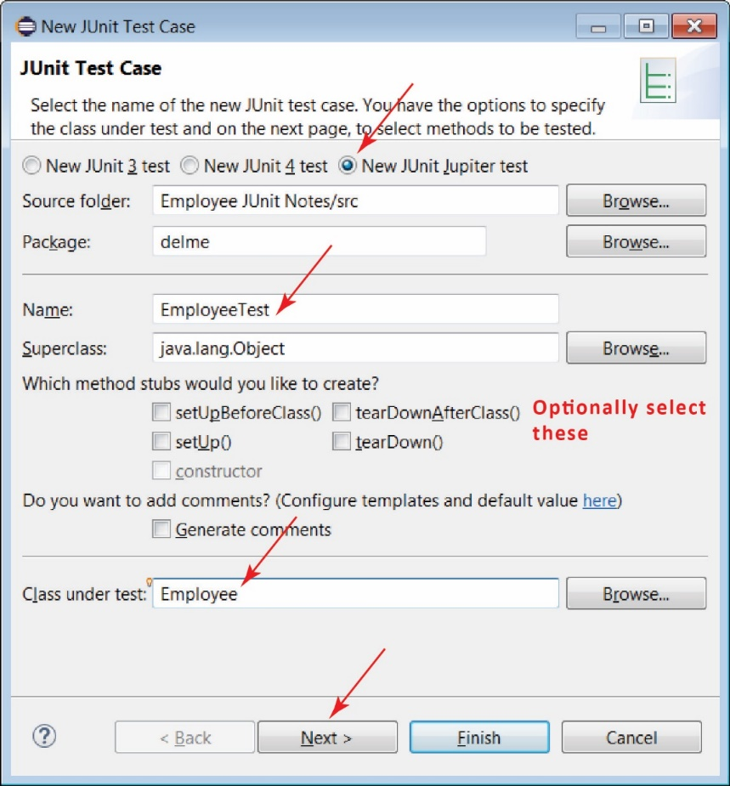JUnit 5 (also called JUnit Jupiter) is the most current framework for doing unit testing in Java. JUnit 5 support is available in Eclipse Oxygen 4.7.1a or higher.
2. To create a JUnit test class in Eclipse, choose:
3. File, New, JUnit Test Case
4. Make sure *New JUnit Jupiter test* is selected
5. Supply a class name. The convention for naming test classes is: *ClassNameTest*. For example, the test class for *Foo* would be *FooTest.*
6. Specify the class under test
7. Next.
8. 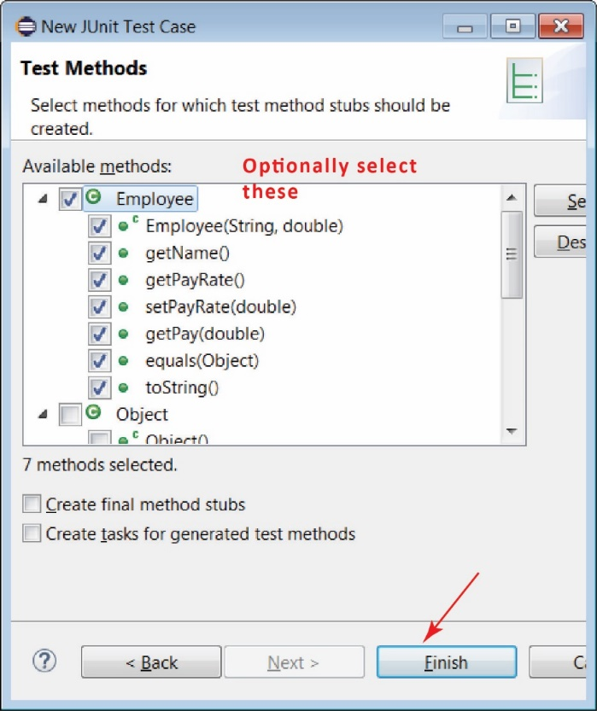On the next dialog, you can choose the methods you want to test and it will create test method stubs for these:
9. The resulting test class will look like this:

**class** EmployeeTest {

@Test

**void** testEmployee() {

*fail*("Not yet implemented");

}

@Test

**void** testGetName() {

*fail*("Not yet implemented");

}

...

}

1. Example – A (abbreviated) set of JUnit tests for the *Employee* class above, might look like as shown below. Note the following:

* A number of imports are required. Most of them must be added by letting Eclipse resolve the compilation error (or typing them yourself)
* The “@Test” annotation is required for a method to be considered a test method which is run automatically.
* The “@DisplayName” annotation is optional; however, it is useful because it appears in JUnit results tab (considered shortly). Thus, it should be descriptive.
* The name of test methods, by convention starts with “test” followed by text that describes the nature of the test. Some people argue that the name should be descriptive; however, I am a bit neutral because it is redundant when using *@DisplayName* which is descriptive. One thing to note is that the order of tests in the JUnit results tab (considered next) is alphabetical based on the name of the test. To me, that argues using a convention so that the first test in the test class is the first test in the display, perhaps naming them *test_01, test_02, etc.*

**import** **static** org.junit.jupiter.api.Assertions.*;

**import** org.junit.jupiter.api.DisplayName;

**import** org.junit.jupiter.api.Test;

**class** EmployeeTest {

@Test

@DisplayName("getPay with hours greater than zero")

**void** test_getPay_positive_hours() {

**double** expectedPay = 800.00;

Employee e = **new** Employee("dg", 20.0);

**double** actualPay = e.getPay(40.0);

*assertEquals*(expectedPay, actualPay);

}

@Test

@DisplayName("getPay with hours less than zero")

**void** test_getPay_negative_hours() {

Employee e = **new** Employee("dg", 20.0);

**double** actualPay = e.getPay(-40.0);

**double** expectedPay = 0.0;

*assertEquals*(expectedPay, actualPay);

}

}

1. To run the test class, simply make sure it is the active window and choose the green run button. The package explorer will display a new tab as shown below. Sometimes it will only run one method. When this happens I click somewhere at the top of the file (outside a method) and then it usually runs all of them.

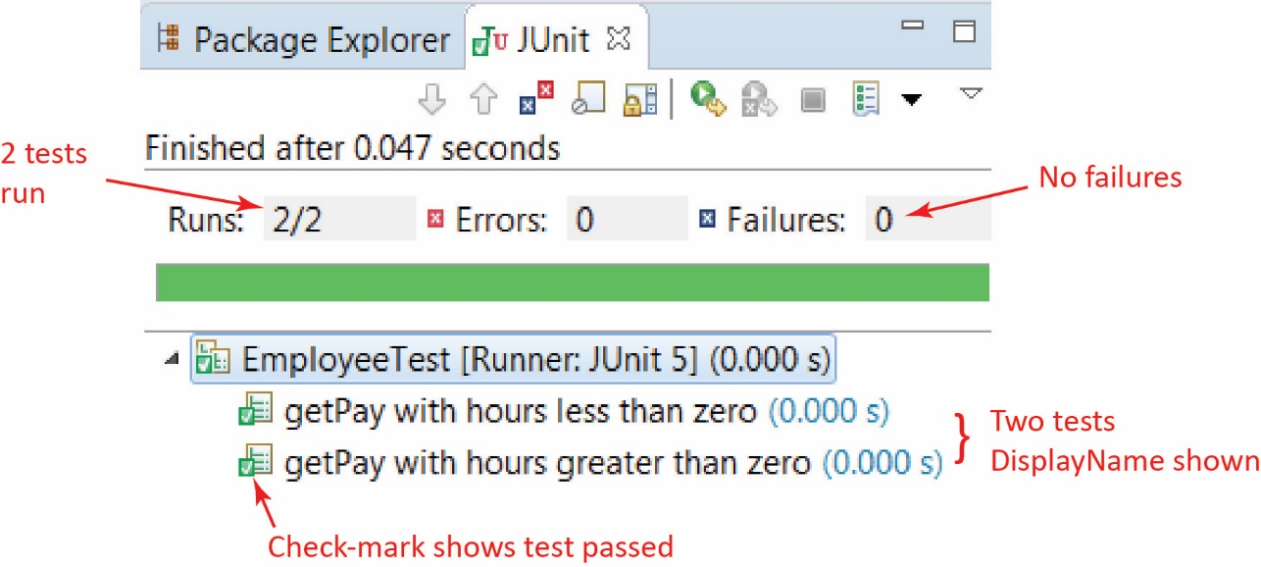

1. If a test fails, the JUnit tab looks like this:

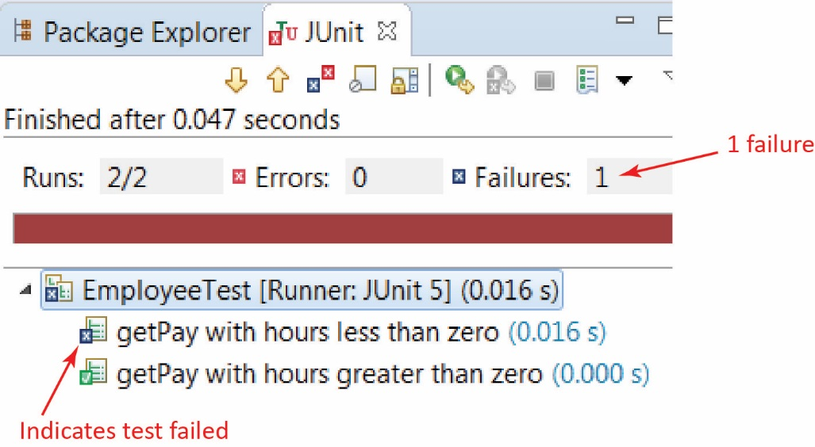

Below this, you will see a Failure Trace pane as shown on the left below. Clicking on the right-most icon in the upper-right displays the Result Comparison dialog. Note that this dialog is not always available (the icon will be grayed out). I’m not sure why.

|  |  |
| --- | --- |
|  |  |

**JUnit API**

1. This is the API for the *Assertions* class that contains all the static *assert…* methods:

<https://junit.org/junit5/docs/current/api/org/junit/jupiter/api/Assertions.html>

Some of the common assert methods most of which we consider next: *assertAll, assertEquals, assertTrue, assertFalse,* *assertArrayEquals, assertIterableEquals, assertNotEquals, assertNotSame, assertNull, assertSame, assertThrows, assertTimeout*

1. JUnit 5 User Guide: <https://junit.org/junit5/docs/current/user-guide/>
2. JUnit 4 FAQ: <https://junit.org/junit4/faq.html>

**JUnit API – *assertEquals(exp,act) & assertSame(Object exp, Object act)***

1. A few basic *assertEquals* are show below and should be self-explanatory: the test passes if both arguments have the same value.

static void assertEquals​(char expected, char actual)

static void assertEquals​(double expected, double actual)

static void assertEquals​(int expected, int actual)

1. This assert below asserts that expected and actual are equal within the given delta, $\left|exp-act\right|≤delta$

static void assertEquals​(double expected, double actual, double delta)

1. To compare two objects you may use: assertEquals(Object exp, Object act). This method uses *equals* to decide if two objects are equal, and hence, return true. If *equals* is not overridden then *Object*’s implementation is used which compares memory locations.
2. 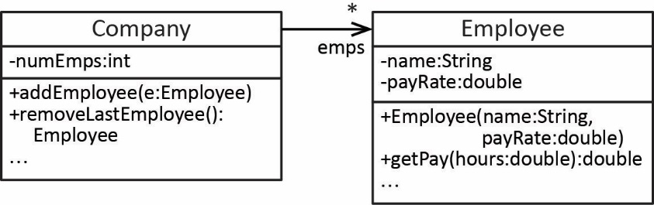Example - Consider the class diagram on the right: a *Company* has many *Employees.*
3. Note the following about the *Employee* class:

* It does not override *equals*.

And the *Company* class:

* It has an array of *Employee* objects which are stored sequentially. For example, if there are three employees, they will occupy positions: 0, 1, 2.
* *addEmployee* adds the argument to the next sequential element in the array.
* *removeLastEmployee* removes and returns the last employee in the array

1. A correct test of the *addEmployee* method is shown below which passes. We add two employees and then call *removeLastEmployee* verifying that it is the same as the second employee added.

Company company = **new** Company();

company.addEmployee(**new** Employee(4334, "Todd", 53.23));

Employee e_Expected = **new** Employee(1393, "Rita", 61.86);

company.addEmployee(e_Expected);

Employee e_Actual = company.removeLastEmployee();

*assertEquals*(e_Expected,e_Actual);

1. An incorrect test of the *addEmployee* method is shown below which fails. It is essentially the same test as the last one; however, *e_Expected* and *e_Actual* are not the same instance as careful examination of the code shows. Thus, you need to be careful about testing object equality.

Company company = **new** Company();

company.addEmployee(**new** Employee(4334, "Todd", 53.23));

company.addEmployee(**new** Employee(1393, "Rita", 61.86));

Employee e_Expected = **new** Employee(1393, "Rita", 61.86);

Employee e_Actual = company.removeLastEmployee();

*assertEquals*(e_Expected,e_Actual);

1. *assertSame(Object expected, Object actual)* – This method returns true if the arguments are the same object. Thus, it is the same as *assertEquals* if the class of the argument does not override *equals*.
2. There is not an *assertEquals(String exp, String act)* overload. However, strings are objects so *assertEquals(Object exp, Object act)* is used to compare strings and *String* overrides *equals* so that two string are equal if they have the same content.

**JUnit API – *assertTrue(booleanExpression) & assertFalse(booleanExpression)***

1. *assertTrue* and *assertFalse* are illustrated in the examples below:
2. The *addMartian* method adds a *Martian* to the *MartianManager* as long as it doesn’t already exist. *Martians* are consider equal if they have the same *id* (the value is passed into the constructor for a *Martian*). It returns true if the add was successful and false otherwise:

@Test

@DisplayName("addMartian return correct when adding RedMartian")

**void** testMartianManager_addMartian_red_successful() {

Martian r1 = **new** RedMartian(8);

*assertTrue*(mm.addMartian(r1));

}

@Test

@DisplayName("addMartian return correct when adding a duplicate")

**void** testMartianManager_addMartian_duplicate() {

Martian r3 = **new** RedMartian(2);

Martian g1 = **new** GreenMartian(11);

Martian g4 = **new** GreenMartian(2);

mm.addMartian(r3); mm.addMartian(g1);

*assertFalse*(mm.addMartian(g4));

}

1. Test that *toString* contains the *id* of a *Martian*:

@Test

@DisplayName("RedMartian toString contains id")

**void** testRedMartian_toString() {

Martian r1 = **new** RedMartian(8);

*assertTrue*(r1.toString().contains(String.*valueOf*(r1.getId())));

}

**JUnit API – *assertArrayEquals(Object[] expected, Object[] actual)***

1. A few basic *assertArrayEquals* are show below and should be self-explanatory: the test passes if there is a one-to-one match in values between elements in the two arrays.

static void assertArrayEquals​(boolean[] expected, boolean[] actual)

static void assertArrayEquals​(char[] expected, char[] actual, String message)

static void assertArrayEquals​(double[] expected, double[] actual)

static void assertArrayEquals​(double[] expected, double[] actual, double delta)

static void assertArrayEquals​(int[] expected, int[] actual)

static void assertArrayEquals​(Object[] expected, Object[] actual)

1. *assertArrayEquals(Object[] expected, Object[] actual) –* Asserts that expected and actual object arrays are deeply equal. Thus, if the class of the array elements override *equals*, then that is used to compare elements. Otherwise, the default *equals* is used which returns true if two elements are the same object. Some examples:
2. If the *Employee* class overrides *equals* such that equality is defined as two instances having the same *name* property, then this test passes:

Employee e1 = **new** Employee("dg", 20.0);

Employee e2 = **new** Employee("ab", 40.0);

Employee[] emps1 = {e1,e2};

Employee e3 = **new** Employee("ab", 90.0);

Employee[] emps2 = {e1,e3};

*assertArrayEquals*(emps1,emps2);

1. Consider the *Company* and *Employee* classes from above. Test to see that *addEmployee* is working correctly. This test passes. Note that since the *Company* class’s *emps* array is protected, we can directly access it as the “actual” argument.

Employee[] empsExpected = **new** Employee[10];

Company company = **new** Company();

empsExpected[0] = **new** Employee("Todd", 53.23);

empsExpected[1] = **new** Employee("Rita", 61.86);

empsExpected[2] = **new** Employee("Suze", 33.93);

**for**(**int** i=0; i<3; i++) company.addEmployee(empsExpected[i]);

*assertArrayEquals*(empsExpected,company.emps);

1. Test to see if *removeLastEmployee* is working. Note that this method does not nullify the element that is removed, it simply decrements the number of employees (see code above). Thus, this test fails because the 4th elements are different. In the “expected” argument it is null; while in the “actual” argument it is: Employee(5911, "Dave", 46.36).

Employee[] empsExpected = **new** Employee[10];

Company company = **new** Company();

empsExpected[0] = **new** Employee("Todd", 53.23);

empsExpected[1] = **new** Employee("Rita", 61.86);

**for**(**int** i=0; i<2; i++) company.addEmployee(empsExpected[i]);

company.addEmployee(**new** Employee("Dave", 46.36));

company.removeLastEmployee();

*assertArrayEquals*(empsExpected,company.emps);

1. A way to fix the previous test is to build an *empsActual* array from the *emps* instance variable:

Employee[] empsActual = **new** Employee[10];

**for**(**int** i=0; i<company.numEmps; i++) {

empsActual[i] = company.emps[i];

}

*assertArrayEquals*(empsExpected,empsActual);

**JUnit API – *assertThrows(Class<T> expectedType, Executable executable)***

1. Asserts that a particular exception is thrown. The *expectedType* can be the actual type of exception that is thrown or any supertype. The *executable* can be specified as a lambda expression.
2. Example:
3. Consider the *getEmployee* method for the *Company* class

**public** Employee getEmployee(**int** i) {

**if**(i<0 || i>numEmps-1)

**throw** **new** IllegalArgumentException("Index i=" + i + " invalid");

**return** emps[i];

}

1. The test below passes. It would also pass when the first argument is: *RuntimeException.class*

Employee[] empsExpected = **new** Employee[10];

Company company = **new** Company();

empsExpected[0] = **new** Employee(4334, "Todd", 53.23);

empsExpected[1] = **new** Employee(1393, "Rita", 61.86);

empsExpected[2] = **new** Employee(8352, "Suze", 33.93);

**for**(**int** i=0; i<3; i++) company.addEmployee(empsExpected[i]);

*assertThrows*(IllegalArgumentException.**class**,

() -> company.getEmployee(99));

1. Note that:

() -> company.getEmployee(99)

is a [lambda expression](https://docs.oracle.com/javase/tutorial/java/javaOO/lambdaexpressions.html) which implements the *Executable* interface. We will not consider these in this class except to note the syntax above: empty parentheses, followed by the “arrow operator”, followed by a line of code. Should you need more than one line of code, surround the lines of code with {}.

**JUnit API – Comparing *ArrayList*’s with *assertEquals(Object expected, Object actual)***

1. You can compare two *ArrayList’s* using *assertEquals* because the *List* interface defines *equals* so that two lists are equal if they have the same elements in the same order.

*Sets* and *Maps* are similar except that the elements don’t have to be in the same order for *HashSet* and *HashMap*.

1. You could also *assertIterableEquals(Iterable<?> expected, Iterable<?> actual)* as *Lists* and *Sets* are *Iterable.*

**JUnit API – *assertAll(Executable… executables)***

1. *assertAll* requires that all asserts inside it (specified as lambda expressions) must be true for the test to pass.
2. Example from: <https://stackoverflow.com/questions/40796756/assertall-vs-multiple-assertions-in-junit5>

Assume you have a simple class like an *Address* with fields *city*, *street*, *number* and would like to assert that those are what you expect them to be. You could write the test like this:

Address address = unitUnderTest.methodUnderTest();

assertEquals("Redwood Shores", address.getCity());

assertEquals("Oracle Parkway", address.getStreet());

assertEquals("500", address.getNumber());

Now, as soon as the first assertion fails, you will never see the results of the second, which can be quite annoying. There are many ways around this and JUnit Jupiter's *assertAll* is one of them:

Address address = unitUnderTest.methodUnderTest();

assertAll("Should return address of Oracle's headquarter",

() -> assertEquals("Redwood Shores", address.getCity()),

() -> assertEquals("Oracle Parkway", address.getStreet()),

() -> assertEquals("500", address.getNumber())

);

**JUnit API – *assertTimeout(Duration timeout, Executable executable)***

1. Asserts that *excutable* completes execution before *timeout* is exceeded. Example:

Company company = **new** Company();

*assertTimeout*(Duration.*ofSeconds*(3),

() -> company.longTask());

**Other Useful JUnit Annotations**

1. Other useful method annotations:
2. *@BeforeAll* – code in this method is run before any tests have been run
3. *@AfterAll* – code in this method is run after all tests have been run
4. *@BeforeEach* – code in this method is run before each test is run
5. *@AfterEach* – code in this method is run after each test is run
6. *@Disabled* – test method is not run
7. Example

**class** EmployeeTest {

@BeforeAll

**static** **void** setUpBeforeClass() **throws** Exception {

}

@AfterAll

**static** **void** tearDownAfterClass() **throws** Exception {

}

@BeforeEach

**void** setUp() **throws** Exception {

}

@AfterEach

**void** tearDown() **throws** Exception {

}

@Test

@DisplayName("Brief description of test")

**void** test() {

*fail*("Not yet implemented");

}

@Disabled("Failing for unknown reason")

@Test

@DisplayName("Brief description of test")

**void** test02() {

*fail*("Not yet implemented");

}

}

1. Tests can also be nested by writing inner classes:

@DisplayName("Tests for HW 5")

**class** HW5_Tester {

@Nested

@DisplayName("Tests for MartianManager class")

**class** MartianManagerTest {

@Test

@DisplayName("addMartian return correct when adding RedMartian")

**void** testMartianManager_addMartian_red_successful() {

*assertTrue*(mm.addMartian(r1));

}

...

@Nested

@DisplayName("Tests for Martian class")

**class** MartianTest {

@Test

@DisplayName("RedMartian toString contains id and volume")

**void** testRedMartian_toString() {

*assertTrue*(r1.toString().contains(String.*valueOf*(r1.getId())));

*assertTrue*(r1.toString().contains("1"));

}

...

}

}

1. You can also define Test Suites which specify which test classes and/or methods to run. There is (was?) a bug in Eclipse and they cannot be run from within Eclipse, but can be run from the command line.

**Guidelines for Writing Unit Tests**

1. A set of JUnit Best Practices that I found useful.

<https://howtodoinjava.com/best-practices/unit-testing-best-practices-junit-reference-guide/>

<http://www.kyleblaney.com/junit-best-practices/>

1. Each test method should do one thing. For example, if testing a stack class, you wouldn’t have a test that tested push, pop, and peek in the same test. However, to pop, you must first have pushed, so, push should be tested first before testing pop.
2. Test methods should be independent. A simple example of non-independent tests is if you have some setup code that sets the state of some class, then run a test method that alters that state, then run a test method that continues to alter that previously-altered state. In other words, each test method should start from scratch.
3. You should not test getters and setters (or any methods) unless they have some logic in them. Similar for constructors as constructors, generally should not have side-effects.
4. Tests should be readable:

“The intent of a unit test should be clear. A good unit test tells a story about some behavioral aspect of our application, so it should be easy to understand which scenario is being tested and — if the test fails — easy to detect how to address the problem. With a good unit test, we can fix a bug without actually debugging the code!”

Source: <https://www.toptal.com/qa/how-to-write-testable-code-and-why-it-matters>

“…In the long run you'll have as much test code as production (if not more), therefore follow the same standard of good-design for your test code. Well factored methods-classes with intention-revealing names, No duplication, tests with good names, etc.”

Source: <https://stackoverflow.com/questions/61400/what-makes-a-good-unit-test>

“Readable … however it can't be stressed enough. An acid test would be to find someone who isn't part of your team and asking him/her to figure out the behavior under test within a couple of minutes. Tests need to be maintained just like production code - so make it easy to read even if it takes more effort. Tests should be symmetric (follow a pattern) and concise (test one behavior at a time). Use a consistent naming convention (e.g. the TestDox style). Avoid cluttering the test with "incidental details”, become a minimalist.

Source: <https://stackoverflow.com/questions/61400/what-makes-a-good-unit-test>

“Rule of thumb here on a failed test report: if you have to read the test's code first then your tests are not structured well enough and need more splitting into smaller tests.” In other words, the *DisplayName* should explain adequately what the test does without having to read the code.

Source: <https://stackoverflow.com/questions/235025/why-should-unit-tests-test-only-one-thing>

1. Another notion in how to test a class with an association to other classes is the idea of sociable tests and solitary tests. For example, suppose class *A* has-a *B*. A *sociable unit testing* approach has unit tests for class *B* and when they pass, unit tests for class *A* are written using the actual *B* class. This is of course not possible if there is two way navigability.

Solitary tests may have unit tests for *B*, but the unit tests for *A* use a mock for *B.*

Source: <https://martinfowler.com/bliki/UnitTest.html>

**Mocking and Test Class Independence**

1. A class under test should be independent of other classes it depends on (has associations with) (or any external resources such as databases, files, *etc.*). There are a number of techniques[1] [2] [3] for doing this including test doubles, mocks, fakes, stubs, and others. We will only consider the general notion of a *mock*. There are two general approaches to mocking:
2. Class-based – If *A* depends on *B* and you want to test A, you create a mock of *B, MockB* that extends *B* and overrides the methods to simply return hard-coded data. For example, suppose the *setB* method in *A* calls *foo* on its *B* instance and does some other processing. To unit test *setB*, we would mock the call to *foo.* In *MockB,* the overridden *foo* simply returns an integer that was supplied in the mock’s constructor.

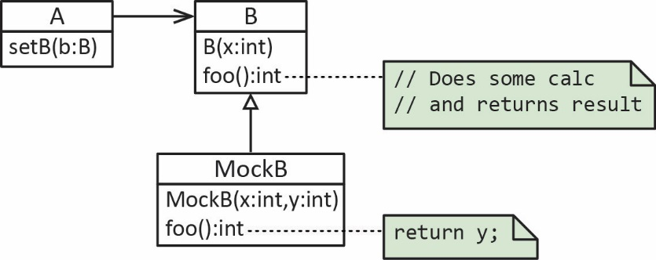

1. Interface-based – Create an interface that both *B* (the real class) and *MockB* implement, similar to the *class-based* approach.

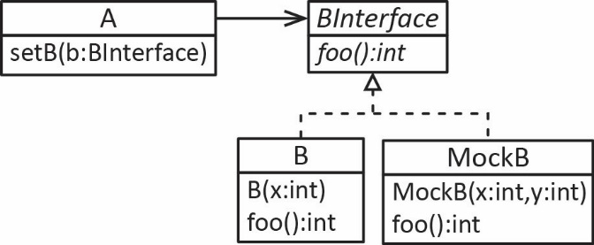

1. Example – Consider the example above where a *Company* has a number of *Employee* objects and that we want to test the *getPayrollTotal* method in the *Company* class:

**public** **double** getPayrollTotal() {

**double** sum=0.0;

**for**(**int** i=0; i<numEmps; i++) {

sum += emps[i].getPay(40);

}

**return** sum;

}

Notice that the method above depends on the *getPay* method in the *Employee* class. Thus, we could create a mock of *B* with:

**public** **class** MockEmployee **extends** Employee {

**private** **double** pay;

**public** MockEmployee(String name, **double** payRate, **double** pay) {

**super**(name, payRate);

**this**.pay = pay;

}

@Override

**public** **double** getPay(**double** hours) {

**return** pay;

}

}

Notice that we are passing in the *pay* to the constructor and that *getPay* simply returns that value. Finally, the unit test would be:

**void** test_getPayRollTotal() {

Employee[] empsExpected = **new** Employee[10];

Company company = **new** Company();

Employee e1 = **new** MockEmployee("Todd", 50.0, 2000.0);

Employee e2 = **new** MockEmployee("Rita", 40.0, 1600.0);

Employee e3 = **new** MockEmployee("Suze", 60.0, 2400.0);

company.addEmployee(e1);

company.addEmployee(e2);

company.addEmployee(e3);

**double** expOutput = 6000.0;

**double** actOutput = company.getPayrollTotal();

*assertEquals*(expOutput,actOutput);

}

Notice that when mocking above, we are only testing *getPayrollTotal* without any possible interference from *getPay*.

1. Manual mocking is occasionally done; however, mostly developers use a mocking framework. Three common frameworks are: [Mockito](https://site.mockito.org/), [JMockit](https://jmockit.github.io/), [EasyMock](http://easymock.org/).
2. This article explains at a high-level, the two major approaches that mocking frameworks take to implement mocking.

<https://dzone.com/articles/the-concept-mocking>

**Integration Testing**

1. Integration testing takes as its input modules (classes) that have been unit tested, groups them in larger aggregates, applies tests. Some approaches:

* Big-bang – Most of the developed modules are coupled together to form a complete software system or major part of the system and then used for integration testing.
* Bottom-up – The lowest level components are tested first, then used to facilitate the testing of higher level components. The process is repeated until the component at the top of the hierarchy is tested.
* Top-down – Top integrated modules are tested and the branch of the module is tested step by step until the end of the related module.
* Sandwich testing is an approach to combine top down testing with bottom up testing.

Source: <https://en.wikipedia.org/wiki/Integration_testing>

1. The term integration testing is used in various ways:

* Narrow integration tests – Uses test doubles and are often no larger in scope than a unit test
* Broad Integration tests – Uses live versions of all services. This is sometimes referred to a *system test* or an *end-to-end* test.
* Some refer to sociable unit tests as integration tests. This is the approach we take.

Source: <https://martinfowler.com/bliki/IntegrationTest.html>

**Code Coverage**

1. Code coverage measures (in percentage) how much of the code is executed when the unit tests are run. Normally, code with high coverage has a decreased chance of containing undetected bugs, as more of its source code has been executed in the course of testing. One such plugin for Eclipse is:

<https://www.eclemma.org/>

**Continuous Integration and Delivery**

1. *Continuous Integration* is the process of merging all working code in branches to the master branch some number of times per day. Its intention is to prevent integration problems.

The longer a branch of code remains checked out, the greater the risk of multiple integration conflicts and failures when the developer branch is reintegrated into the main line. When developers submit code to the repository they must first update their code to reflect the changes in the repository since they took their copy. The more changes the repository contains, the more work developers must do before submitting their own changes.

Eventually, the repository may become so different from the developers' baselines that they enter what is sometimes referred to as "merge hell", or "integration hell", where the time it takes to integrate exceeds the time it took to make their original changes.

Continuous integration involves integrating early and often, so as to avoid the pitfalls of "integration hell". The practice aims to reduce rework and thus reduce cost and time.

A complementary practice to CI is that before submitting work, each programmer must do a complete build and run (and pass) all unit tests. Integration tests are usually run automatically on a CI server when it detects a new commit.

Source: <https://en.wikipedia.org/wiki/Continuous_integration>

For practical purposes, nearly every CI setup uses automated test suites. When code is ready to merge, an automated process kicks off a new codebase build. The automation also runs a suite of quality assurance tests to check for bugs and determines if the update introduces integration problems. Continuous delivery is the next step after CI, in which you also automate release cycles.

Source: <https://www.hpe.com/us/en/insights/articles/continuous-integration-and-delivery-tool-basics-1807.html>

1. [Gradle](https://gradle.org/) is a framework and API that is used for CI and possibly CD. It can be found in Eclipse by choosing: File, New, Project and choosing Gradle.
2. [Maven](https://maven.apache.org/) is similar and also supports reporting and documentation. It is also available in Eclipse.

**Example**

Here, we consider unit and integration testing for the Student-Course example. The code is on the Schedule and is found in the *ver4* package. Code will be explained in class.

**Interviews with Developers about Testing**

|  |  |
| --- | --- |
| Interviewee: | VSU CS Graduate |
| Company: | Rally Software – Develops tools/platform that supports agile software development. |
| Time Frame: | 2018 |

* Codebase of 200K lines of code (LOC) was refactored, removing about 50K LOC, leaving the code base about 150K LOC
* 3500 unit tests totaling about 60K LOC, about 4.5 minutes to run. Employee mocks for database and other external services.
* 7000 integration tests, about 12 minutes to run.
* End-to-end testing, tests the entire stack. 8.5 hours to run. Uses browser automation. After a project to speed this up, reduced to 20 minutes.

|  |  |
| --- | --- |
| Interviewee: | VSU CIS Graduate |
| Company: | IBM – WebSphere Application Server, framework that hosts Java based web applications |
| Time Frame: | 2005 (updated in 2012) |

* Product: IBM's WebSphere Application Server. 600 programmers, 300 testers.
* The software lifecycle conforms to ISO standards as some customers require this. These standards basically spell out the software development process: practices, documents, players, signoffs,...
* Test group has areas: configuration testing, language verification testing, functional testing, system testing (longer form tests), and performance testing (stress loads).
* 23 Operating systems, 13 languages. Very few bugs are operating system specific. So, for a given product version test, only 2-3 operating systems may be used.
* All testing is currently Black Box testing. The philosophy is, "use it like the customer would." In the past (as recent as 5 years ago?), extensive white-box testing was done.
* Test plans define the test and what areas will be tested, what areas have changed, and map to target release dates.
* Tests are written as *Scenarios* with a very detailed description of the assumptions and setup.
* Regression testing is essential, but balanced with economics.
* Automated testing has its economic tradeoffs. You can put a lot of time into developing an automated test that can be rerun at any time. However, most testing is not automated in this way due to the economics. Automated testing is also problematic in software that is being constantly updated because constant changes often confuse the automation. Automation is best used for regression testing to ensure that new changes have not broken established functionality.
* On a recent project, he managed a group of 80 testers; 60 on-site and 20 in China. After the scenarios are made, he spends lots of his time making graphs of defect rates and other statistics. He recently wrote a program in VB to automate the graph making process.
* Defects (which occur by the hundreds) are tracked in a database with detailed descriptions of the errors and relevant output. They are also ranked with a severity code. Engineers try to fix them and return the code for retesting.
* Outsourcing has its benefits and drawbacks. Average cost of labor is $100,000 in US and $15,000 in China, about 7 times less than the US. Testers corresponding with software developers in China can take time. Ask a question, get response 12 hrs. later, 12-hour cycle. Are they as good? Probably not, in his opinion, but are they at least 1/7 as good? That is the economic question.
* All products go out the door with defects. It is economics again.
* At IBM and many other companies testing is a viable career path. Compensation is similar to the pay for developers.

1. <https://martinfowler.com/bliki/TestDouble.html>
2. <http://engineering.pivotal.io/post/the-test-double-rule-of-thumb/>
3. <https://en.wikipedia.org/wiki/Test_double>